Creating a Virtual Machine Scale Set Problem Statement:
Create a virtual machine scale set Description: You will create a Linux virtual machine scale set.
Step 1: Go to the Azure service ‘Virtual machine scale sets’ from the search bar and click on ‘Add’
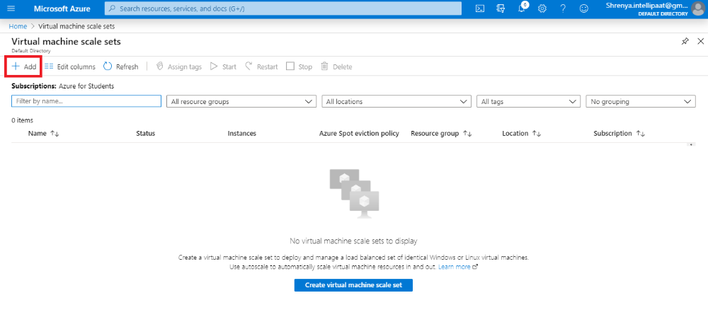

Step 2: Fill in the details as required
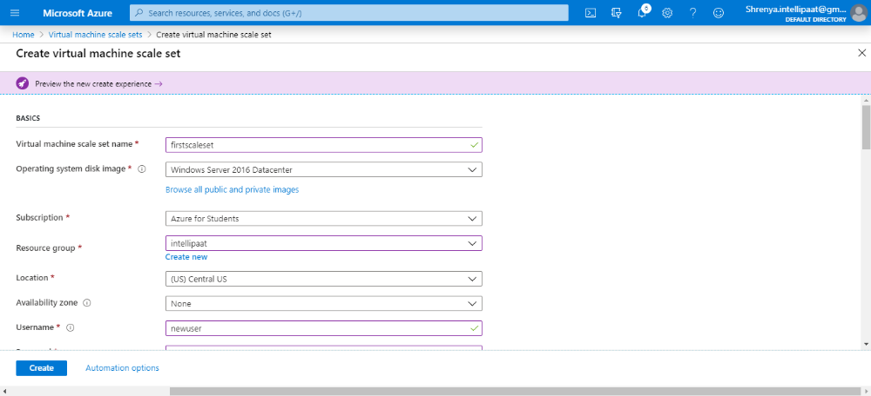
Step 3: Enter the instance count and the preferred instance size
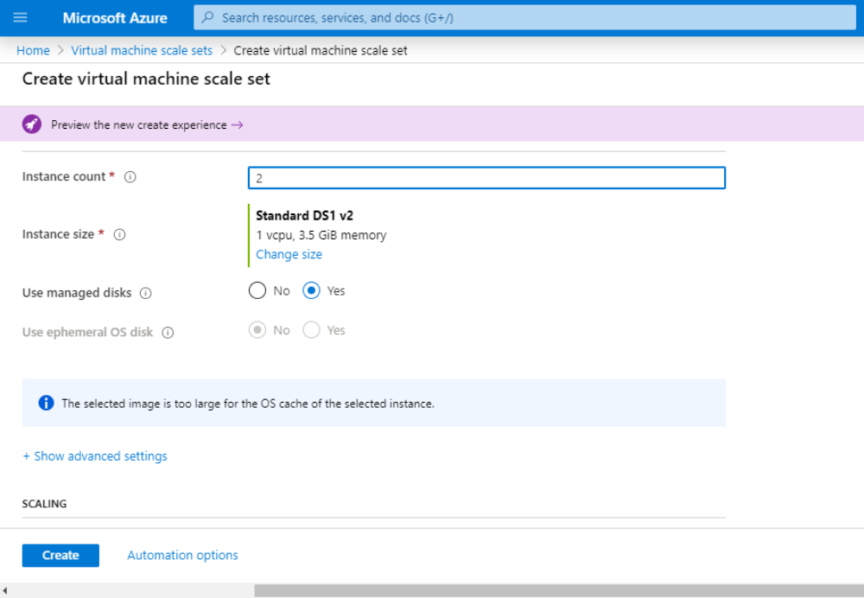
Step 4: Enable scaling if it is required. If you go for it, it will ask for details such as the CPU threshold for increasing and decreasing the number of VMs
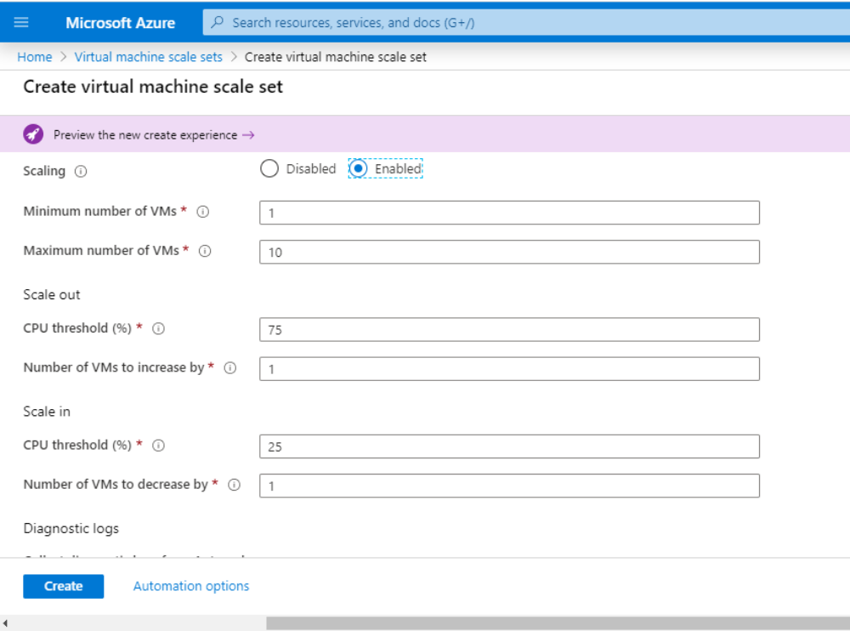
Step 5: Choose the load balancing options such as Virtual network, Application gateway, or Load balancer. Create a virtual network if it hasn’t been deployed before. Click on ‘Create’
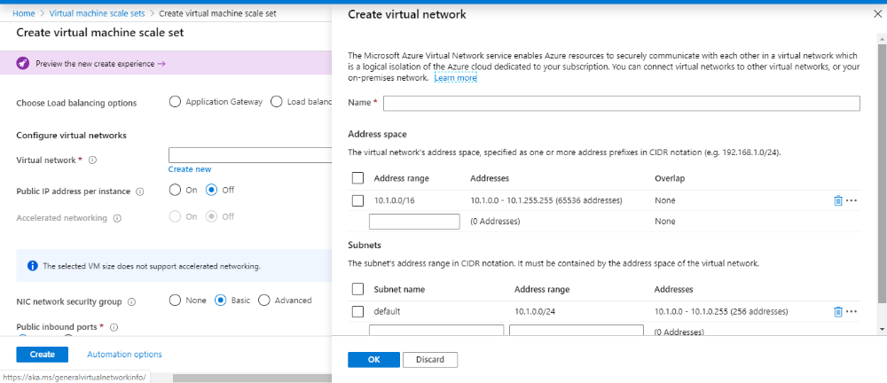
Step 6: Go to the resource to check if the scale set is up and running
